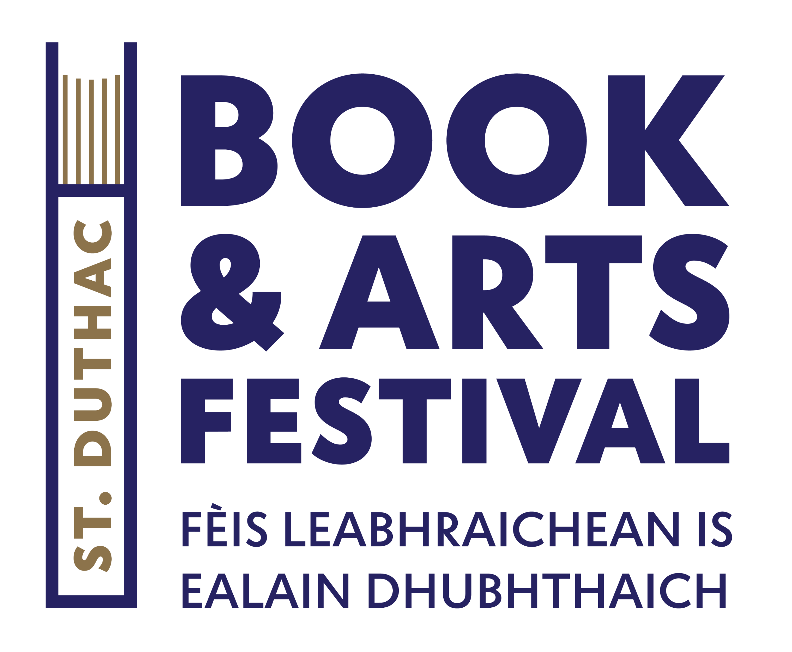
Thank you for your interest in the St Duthac Book and Arts Festival, we really couldn’t do it without the wealth of enthusiastic authors and artists. Please fill in this form if you would like to be considered for inclusion next year’s festival programme.
First Name:
Surname:
Home phone number |  |  |  | Mobile phone number
Email address
Are you an ….

Author |  | Artist |  | Other (please specify): ………………………………………………………………….
Where are you based?

Author Name of publisher.

How would you like to take part? Please tick all that apply.
 | Live speaker event during festival.
 | Pop Up author in our pop-up bookshop.
 | Art exhibition in satellite location.
 | Artist in pop-up bookshop.
 | Other:
 | Other:

Authors, artists, and performers please include a 50-word bio and photograph.

Please include an image and 50-word synopsis of your latest work. Please include genre.

Live speakers please include synopsis of your proposed live event.

What happens next?
On receipt of your pitch, we will contact you to acknowledge receipt.
Then during the month of November, we will review all pitches and will re-connect with you in due course to tell you if your pitch has been successful.
Additional Information

